Guided Capstone Project Report

After analyzing over 300 Ski resorts across the United States and building a model to predict pricing, we can recommend a modest ticket price increase of about $5 and that we drop our least popular run and add another to support another $9 ticket price increase.

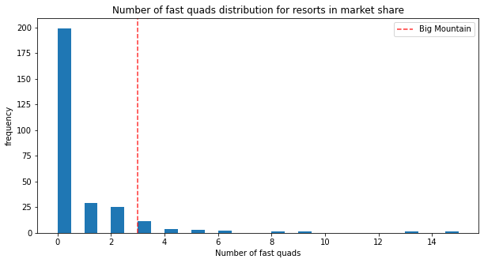

And as you can see, Big Mountain Resort is well above the average when compared to the competition in many of these. Its ticket price, however, sits near the middle of the pack nationwide, and is equally priced with the most expensive in Montana. Chart, histogram

Because of Big Mountain’s exceptional offerings, compared to competition, we do recommend a price increase, but because it is already a premium compared to Montana resorts, we do not recommend the $15 ticket price increase predicted by the model, but rather a more conservative $5 dollar increase to the low end of the average error predicted by the model. This price increase, with the assumed attendance and average 5-day stay would amount to a revenue increase of $8.75 million, which well covers (and justifies) the cost of the chair lift upgrade.

## Other Changes to Consider

We modelled a few of the changes that Big Mountain is considering and can show what the expected revenue changes would be.

### Closing runs

Here are the is what the model predicts the effect closing runs would have on supported ticket price and revenue. As you can see, the effect of closing one run to either is nothing, and thus we conclude that keeping it open is just costing Big Mountain in operating cost. We recommend closing it.

### Adding a run, Increasing the vertical drop by 150 feet, and Installing an extra chair lift

This scenario increases support for ticket price by $8.61. Over the season, this could be expected to amount to ~ $15 million

### Same as above, also Adding 2 acres of snow making area

Predicted increase from the above scenario is only $2 Million so it is not advisable.

## Conclusion:

While it might seem risky, the data suggests that a ticket price increase will result in a revenue increase for Big Mountain, that alone would cover the cost of its recent upgrade. If the company wishes to take some more incremental steps, then closing the least popular run is predicted to be a good neutral decision to save some cost. If instead the company wishes to expand, adding a run as described above with a chair lift is predicted to pay for itself in a single season with expected attendance.